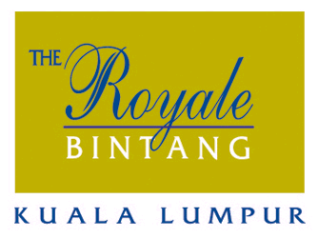
HOTEL RESERVATIONS FORM
SIBR – UNIKL CONFERENCE ON INTERDISCIPLINARY BUSINESS & ECONOMICS RESEARCH
12 &13 FEBRUARY 2016, KUALA LUMPUR, MALAYSIA

KINDLY COMPLETE THE HOTEL RESERVATION FORM AND FAX BACK THE FORM TO ‘OUR RESERVATION’ DEPARTMENT AT (603) 2142 1807 / 2145 9588 OR E-MAIL TO resvn@royale-bintang-hotel.com.my : CC copy to: farahiyah@royale-bintang-hotel.com.my , resvn.supv@royale-bintang-hotel.com.my

PERSONAL INFORMATION
Name (s) : ______________________________________________________________________________

Address : ______________________________________________________________________________

______________________________________________________________________________

Telephone no: ___________________________ Fax no. : ___________________________

Email address: ______________________________________________________________________________

ROOM RESERVATION DETAILS

Check in date : _________________________ Check out date: _________________________

Superior Room RM270.00+ (RM286.20nett) per room per night

Deluxe Room RM280.00+ (RM296.80nett) per room per night
Inclusive of
- One night accommodation
- Buffet Breakfast at The Sunflower Brasseries for up to two (02) persons
- Wireless Internet Access

*Deluxe Club Room RM360.00+ (RM381.60nett) per room per night

*Executive Suite RM485.00+ (RM514.10nett) per room per night
*Inclusive of
- One night accommodation
- Access to The Royale Club Lounge on the 18th Floor
- Buffet Breakfast at The Sunflower Brasseries or Royale Club Lounge
- Wireless Internet Access

All room rates quoted are subject to 6% government tax
Official check-in at 2pm & check-out at 12noon

PAYMENT
Room reservation must be guaranteed through the use of major credit card or by submitting a deposit of one night’s room charge inclusive of tax. Cancellation or No Show within 72 hours before arrival, will be charged at one night.

Credit Card no: ___________________________ Credit Card Type: ________________________
Expiry Date: ___________________________ 3 digit security code: _______________________

Signature Cardholder: __________________

I authorized The Royale Bintang Hotel Kuala Lumpur to charge my credit card for one night room charge inclusive of the tax.

You may also bank in to: BOUSTEAD HOTELS & RESORTS SDN BHD
Malayan Banking Berhad
Branch A/C No: 0140-8433-6109
Swift Code: MBB EMY KL

